## API Keys for frontend guide

#### **Google Maps**

**https://console.cloud.google.com/google/maps-apis/overview**

* Need to follow the instructions to put in your details to set up an account (can use the free option for the project)
* Then set up an API key

<https://developers.google.com/maps/documentation/javascript/get-api-key?hl=en-GB>

* Then in your Google Maps console you add the **Maps Javascript AP**I to your ‘allowed’ APIs

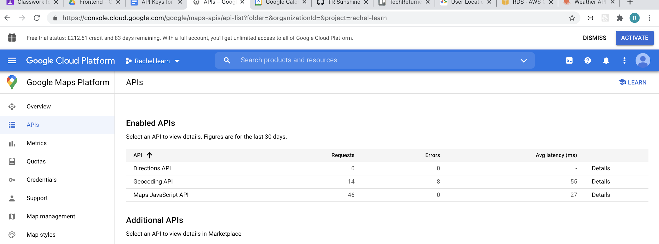

**OpenWeather Map**

Sign up to create an account and get an API key:

<https://home.openweathermap.org/users/sign_up>

**Add keys to your project**

* Create an .env file in the root of your project
* Add the following:

REACT_APP_WEATHER_API_KEY=exampleopenweatherkey

REACT_APP_GOOGLE_API_KEY=examplelgooglekey

The code is already set up to refer to those key names. N.b. don’t put a semi-colon (I was stuck on that for a while in a different project ;-) )

May sure you have got dotenv installed in your node modules (it probably is if you have done npm install recently, but worth checking.)